Bibliography

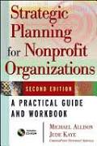
Strategic Planning for Nonprofit Organizations: A Practical Guide and Workbook, Second Edition
by Michael Allison, Jude Kaye
Publisher: Wiley; 2 edition (July 11, 2003)
ISBN-10: 0471445819
ISBN-13: 978-0471445814
Spiritual Leadership for Church Officers: A Handbook
by Joan S. Gray
- Publisher: Geneva Press (June 2, 2009)
- ISBN-10: 0664503055
ISBN-13: 978-0664503055

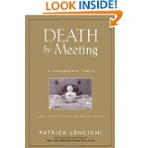
Death by Meeting: A Leadership Fable...About Solving the Most Painful Problem in Business
by Patrick Lencioni
Publisher: Jossey-Bass; 1 edition (March 4, 2004)
ISBN-10: 0787968056
ISBN-13: 978-0787968052

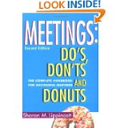
Meetings: Do's, Don’ts and Donuts: The Complete Handbook for Successful Meetings
by Sharon M. Lippincott
Publisher: Lighthouse Point Pr; 2 edition (February 1999)
ISBN-10: 0963796666
ISBN-13: 978-0963796660
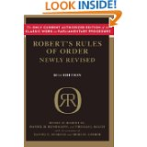
Robert's Rules of Order Newly Revised, 11th edition
Henry M. III Robert (Author), Daniel H. Honemann (Author), Thomas J. Balch (Author), Daniel E. Seabold (Contributor), Shmuel Gerber (Contributor)
Publisher: Da Capo Press; 11th Edition edition (September 27, 2011)
ISBN-10: 030682020X
ISBN-13: 978-0306820205

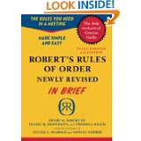
Robert's Rules of Order Newly Revised In Brief, 2nd edition (Roberts Rules of Order in Brief)
Henry M. III Robert (Author), Daniel H. Honemann (Author), Thomas J. Balch (Author), Daniel E. Seabold (Contributor), Shmuel Gerber (Contributor)
Publisher: Da Capo Press; Second Edition edition (September 27, 2011)
ISBN-10: 0306820196
ISBN-13: 978-0306820199

Bates, Suzanne, “Learning to Lead: Five Steps to Pain-free, Productive Meetings,” Web, October, 2018 http://www.myarticlearchive.com/articles/6/122.htm

The Official Robert’s Rules of Order Website, Web October, 2018 http://www.robertsrules.com/faq.html

“How to Lead Effective Meetings,” Academic Leadership Support, University of Wisconsin,
Web October, 2018 https://www.ohrd.wisc.edu/AcademicLeadershipSupport/LeadMeetings/tabid/74/Default.aspx

Wilson, Brandon D, “28 of the most annoying things about meetings and how to solve them”
Web, October, 2018
https://theascent.pub/28-of-the-most-annoying-things-about-meetings-and-how-to-make-meetings-meaty-f79a70d77f2d

